|  |  |
| --- | --- |
| *Pacific Gas and Electric Company* | |
| Patch 7.5.4 Installation Guide | |
|  |  |
|  |  |
| Project | ED AM/GIS |
|  |  |
| Prepared by | Corey Blakeborough |
| Date | 7/25/2013 |
| Version | 5.0 |
| Version Type | Final |

Table of Contents

1 Introduction 4

1.1 Purpose 4

1.2 Terms Used 4

1.3 TFS Reference 4

1.4 External Documents 4

1.5 Summary of Steps to Complete Patch 5

2 Set Up ArcCatalog Connection 7

3 Change Origin Relationship Cardinality 9

4 Recreate CustAgreeNumberAnno Feature Class 11

5 Modify Annotation Feature Class 26

5.1 Modify StepDownAnno 26

5.2 Modify SupportStructureAnno 35

5.3 Modify TransformerAnno 42

5.4 Modify DynamicProtectiveDeviceAnno 56

6 Modify Privileges For Electric Dataset 64

7 Update Data Model Version Table 66

8 Known Issues 67

|  |  |  |  |
| --- | --- | --- | --- |
| Revision History | | | |
| Document # | Date | Author | Summary of Changes |
| 1.0 | July 16, 2013 | Corey Blakeborough | Initial Document Creation |

# Introduction

## Purpose

This document is intended to detail the implementation and configuration steps required to implement the ED AM/GIS 7.5.4 data model release. This document describes the various configuration aspects required to complete any manual or automatic patch associated with this release. Each section in this document contains the steps required to patch the system in production.

## Terms Used

|  |  |
| --- | --- |
| OOTB | Out of the box. Unmodified from the commercial version. |
| TFS | Team Foundation Server |

## TFS Reference

The change requests that constitue the 7.5.4 data model release may be found in TFS using the following information.

|  |  |  |  |
| --- | --- | --- | --- |
| Ticket # | | Work Item Type | Title |
| [8843](http://edappgistfsprd1:8080/tfs/ElectricDistCollection/EDAMGIS/_workitems/edit/8843) | | Change Request | Master 7.5.4 Data Model Changes |
| [8602](http://edappgistfsprd1:8080/tfs/ElectricDistCollection/EDAMGIS/_workitems/edit/8602) | Change Request | Generator: Origin Cardinality Changes |
| [8728](http://edappgistfsprd1:8080/tfs/ElectricDistCollection/EDAMGIS/_workitems/edit/8728) | Change Request | Change CustagreeNumberAnno Reference Scale |
| [8775](http://edappgistfsprd1:8080/tfs/ElectricDistCollection/EDAMGIS/_workitems/edit/8775) | Change Request | Bug 8128: Set Default Value For Transformer:SpotIDC Field |
| [8806](http://edappgistfsprd1:8080/tfs/ElectricDistCollection/EDAMGIS/_workitems/edit/8806) | Change Request | Bug 1399: Changes To StepDownAnno Feature Class |
| [8807](http://edappgistfsprd1:8080/tfs/ElectricDistCollection/EDAMGIS/_workitems/edit/8807) | Change Request | Bug 1805: Changes To SupportStructureAnno Feature Class |
| [8808](http://edappgistfsprd1:8080/tfs/ElectricDistCollection/EDAMGIS/_workitems/edit/8808) | Change Request | Bug 3623: Changes To TransformerAnno Feature Class |
| [8809](http://edappgistfsprd1:8080/tfs/ElectricDistCollection/EDAMGIS/_workitems/edit/8809) | Change Request | Bug 8146: Changes To DynamicProtectiveDeviceAnno Feature Class |
| [8835](http://edappgistfsprd1:8080/tfs/ElectricDistCollection/EDAMGIS/_workitems/edit/8835) | Change Request | Bug 8833: Joint Owner Table, Domain Change On Field |

## External Documents

Referenced are any external configuration documents or exports. These are documents that contain more detailed information about configuring a system or documents that can be loaded into an application to perform the configuration detailed in this document.

* *No external documents*

## Summary of Steps to Complete Patch

These are the high-level steps to complete the installation and configuration of the data model patch. Use this table as a guide for completing the installation. Links are provided that can lead either within the document for detailed explanations or to external sites such as Sharepoint.

|  |  |  |  |
| --- | --- | --- | --- |
|  | **Step Name** | **Description** | **Document Link** |
|  | Configure ArcCatalog Connection | Connect to the target database as *edgis* in ArcCatalog, creating a new named connection if necessary. | Set Up ArcCatalog Connection  **Note: If an appropriate connection already exists, SKIP THIS STEP.** |
|  | Run Python Scripts | Download the following Python scripts via TFS attachments:   * [8775](http://edappgistfsprd1:8080/tfs/ElectricDistCollection/EDAMGIS/_workitems/edit/8775) * [8835](http://edappgistfsprd1:8080/tfs/ElectricDistCollection/EDAMGIS/_workitems/edit/8835)   Change each script to reference the connection established in step 1.  Execute each script. |  |
|  | Change Generator Origin Cardinality | In ArcCatalog, open the properties of the ProtectiveDevice_Generator relationship class.  Change *all* minimum origin cardinality values to **0**. | Change Origin Relationship Cardinality |
|  | Change CustAgreeNumberAnno Reference Scale | In ArcCatalog, delete and recreate the CustAgreeNumberAnno annotation feature class, changing the reference scale of the *Default* annotation class from 1:12,000 to **1:1,200**. | Recreate CustAgreeNumberAnno Feature Class |
|  | Change Annotation Feature Class Properties for StepDownAnno | Make specified changes to each annotation class per the TFS ticket description. | Modify StepDownAnno |
|  | Change Annotation Feature Class Properties for SupportStructureAnno | Make specified changes to each annotation class per the TFS ticket description. | Modify SupportStructureAnno |
|  | Change Annotation Feature Class Properties for TransformerAnno | Make specified changes to each annotation class per the TFS ticket description. | Modify TransformerAnno |
|  | Change Annotation Feature Class Properties for DynamicProtectiveDeviceAnno | Make specified changes to each annotation class per the TFS ticket description. | Modify DynamicProtectiveDeviceAnno |
|  | Update Data Model Version Table | Connect to the same server used in step 1 using *SQL Plus* as the edgis user, and run the following SQL:  update pgedatamodelversion set currentidc='N' where currentidc='Y';    insert into pgedatamodelversion (OBJECTID, CURRENTIDC, DATEAPPLIED, APPLIEDBYPERSONNAME, MODELVERSION) values (25,'Y',sysdate,'Rob Rader','7.5.4 CR8843'); | Update Data Model Version Table |

# Set Up ArcCatalog Connection

Set up a connection in ArcCatalog to use for both automatic and manual patching.

1. Open ArcCatalog.
2. Within the Catalog Tree, expand “Database Connections” and click “Add Spatial Database Connection”.  
     
   
3. Fill in the attributes as shown below. Modify as necessary to reach the correct database.  
     
   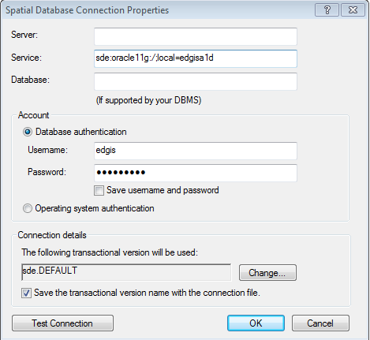

sde:oracle11g:/;local=edgisg1d

1. Click “OK”.
2. The connection will appear on the right side of the window in the Contents tab. Rename the connection appropriately.  
     
   
3. If the full path of this connection is needed, retrieve from in the following default location (path may vary based on installation and operating system):  
   C:\Users\[LAN ID]\AppData\Roaming\ESRI\Desktop10.0\ArcCatalog\[FILENAME].sde
4. Double-click on the connection within ArcCatalog to open it.

# Change Origin Relationship Cardinality

1. Open ArcCatalog.
2. Within the Catalog Tree, expand “Database Connections” and open the active connection for this process (as defined in section 2).
3. Within the root of the connection, right-click on the “ProtectiveDevice_Generator” relationship class and click “Properties”.
4. In the top “Origin” list, select the “Protective Device” option. Subtypes in the below “Destination” list will activate.  
     
   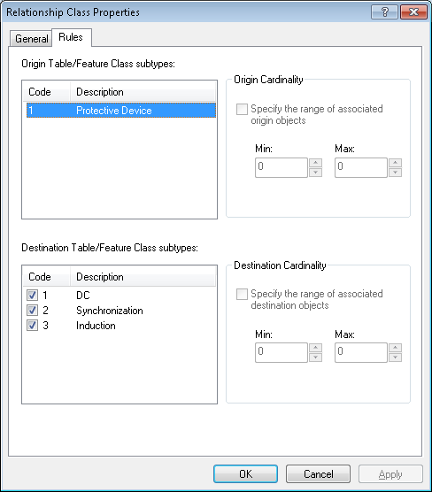
5. Click on **each** subtype in the below “Destination” list, changing the “Min” field in the “Origin Cardinality” box to **0**. Make sure this is done for all subtypes in the “Destination Table/Fetaure Class subtypes” area  
     
   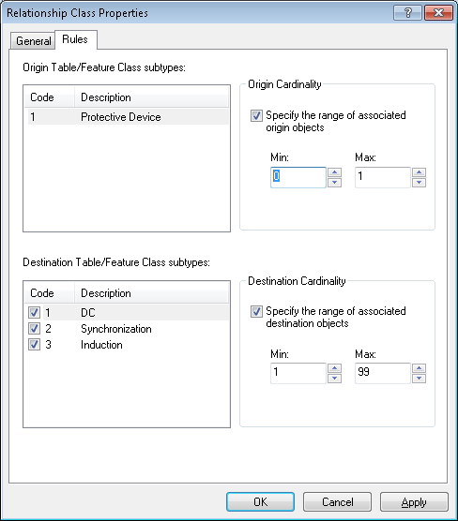
6. Click “OK”.

# Recreate CustAgreeNumberAnno Feature Class

1. Open ArcCatalog.
2. Within the Catalog Tree, expand “Database Connections” and open the active connection for this process (as defined in section 2).
3. Within the ElectricDataset, right-click on the CustAgreeNumberAnno class and choose to delete it. Confirm the deletion if prompted.
4. Right click on the ElectricDataset and choose New 🡪 Feature Class.  
     
   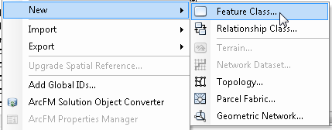
5. Fill out the form to match the screen below, then click “Next”.  
   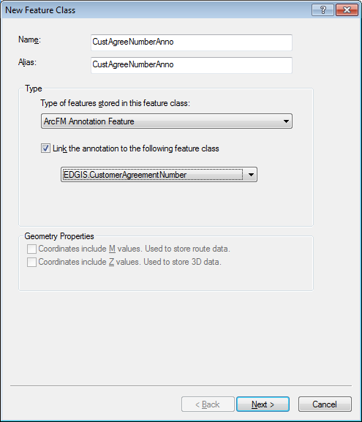
6. Be sure to change the reference scale to **1:1,200** as shown below. Match the settings to the example below, then click “Properties” next to the Label Engine.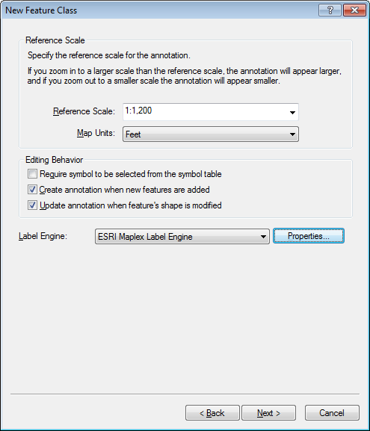
7. On the resultant screen, change the “Orientation of Vertical Levels” setting to **5**. Click OK.  
   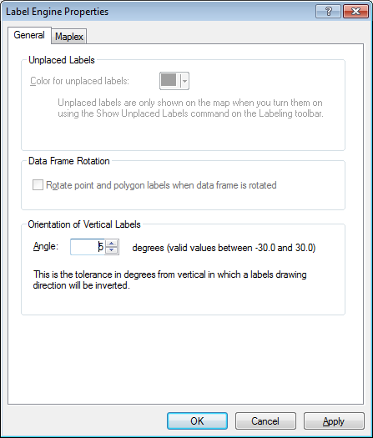
8. Click “Next”.
9. Change the settings for the *Default* annotation class to match the settings provided in the example below.  
   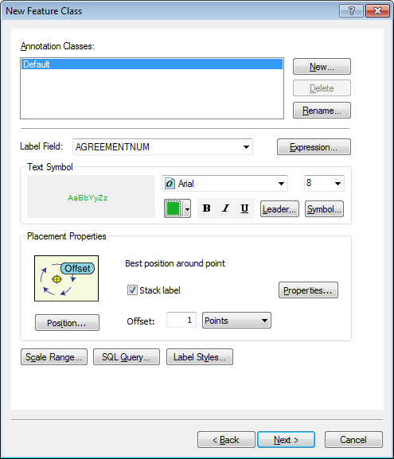
10. Click “Expression” next to the Label Field dropdown.



1. Ensure that the “Display coded value description” checkbox is selected, match the label text with the text below, click verify, and then click “OK”.   
   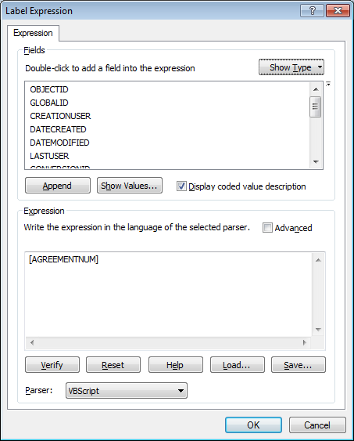

[AGREEMENTNUM]

1. Click on the “Leader” button next.   
     
   
2. Verify that the settings match the example below. Click “OK” when finished.  
   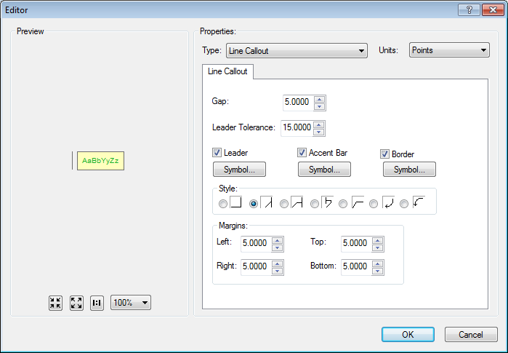
3. Click on the “Symbol” button.  
     
   
4. 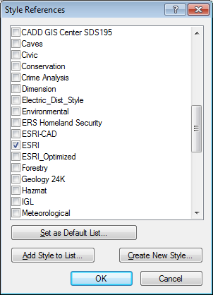Verify that the settings match the below area.   
   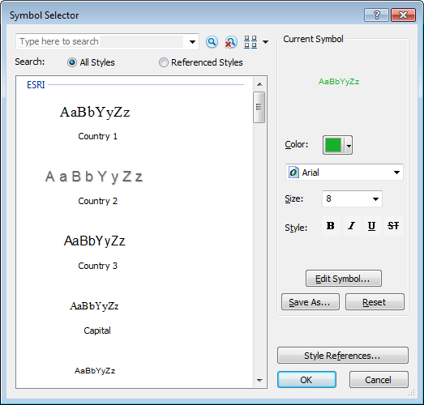

If the “ESRI” style group does not show up, click “Style References” and ensure that it is selected, and then click “OK”.

1. On the Symbol Selector window, choose “Edit Symbol”.
2. Match the settings in all four tabs shown below.

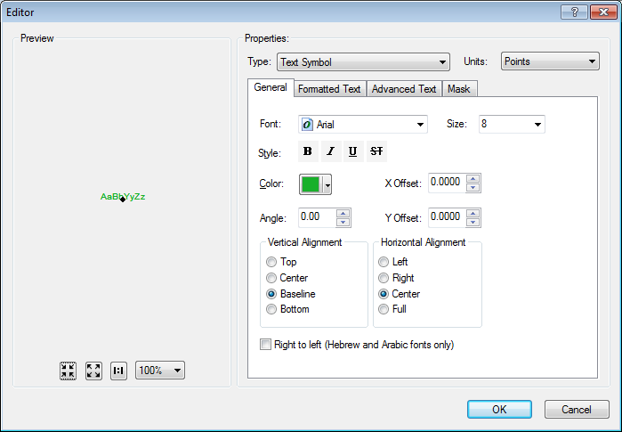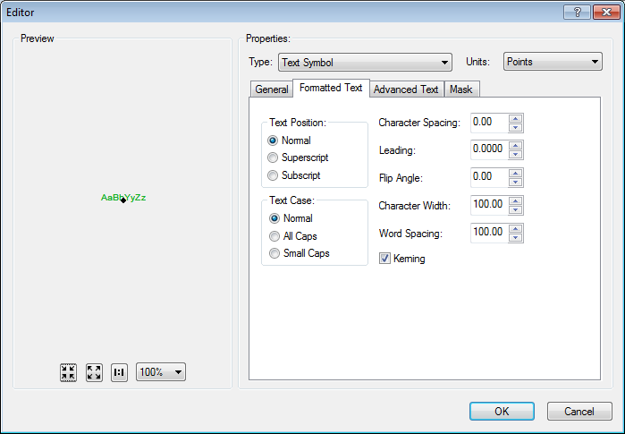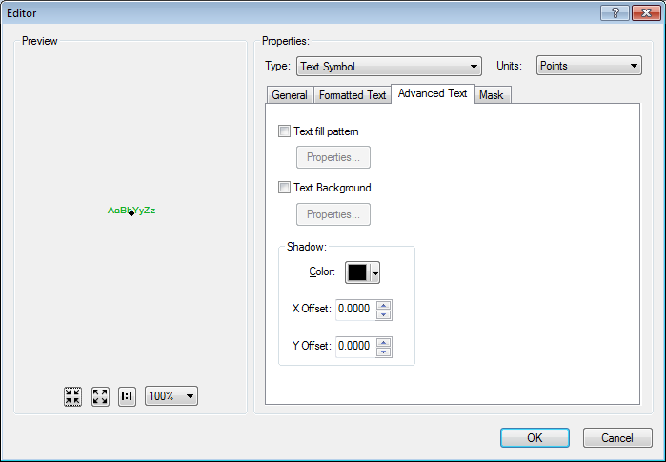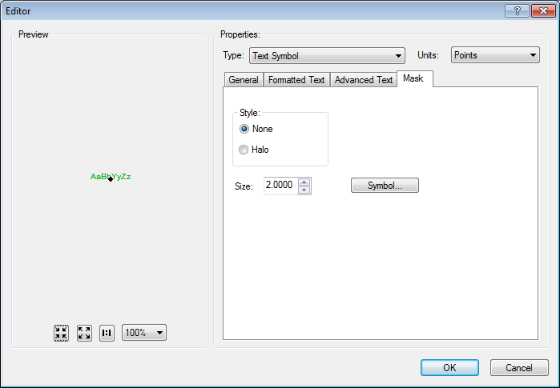

1. Click “OK” to close out of the Style Editor Window.  
   Click “OK” to close out of the Symbol Selector Window.
2. On the New Feature Class screen, choose “Properties” under “Placement Properties”.  
   
3. Verify that the settings match the below examples for Label Position, noting the values of the windows that appear after clicking the “Position”, “Label Offset”, and “Orientation” buttons.

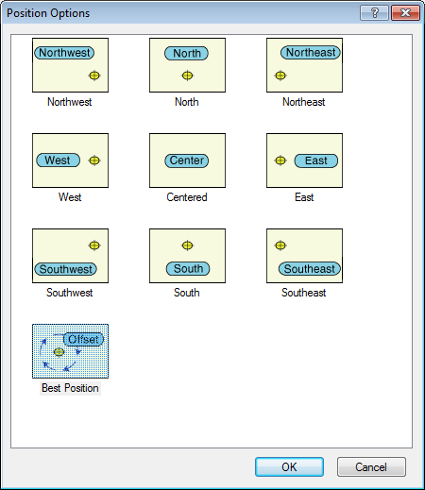

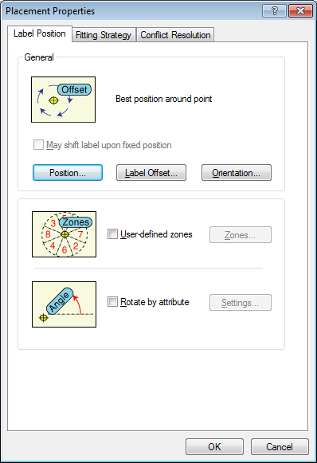

.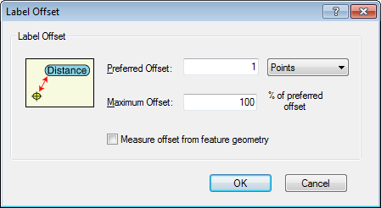 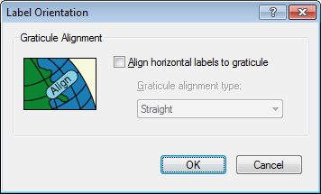

1. Verify that the settings match the below examples for the remaining two Placement Properties tabs.

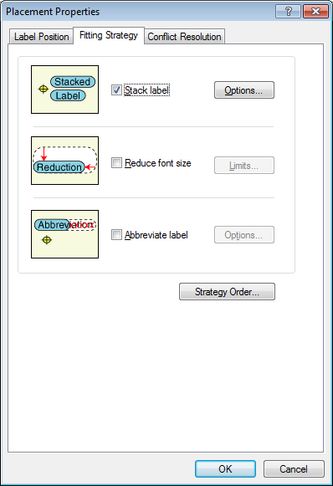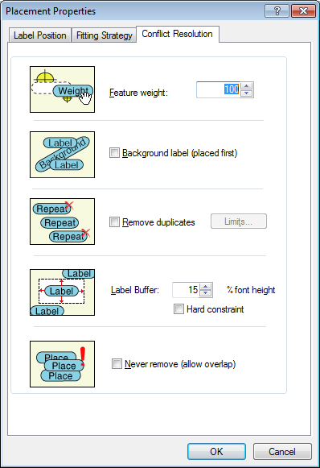

1. Click “OK” to close out of the Placement Properties window.
2. On the “New Feature Class” screen, click “Next”.
3. Specify the “Default” configuration keyword.  
    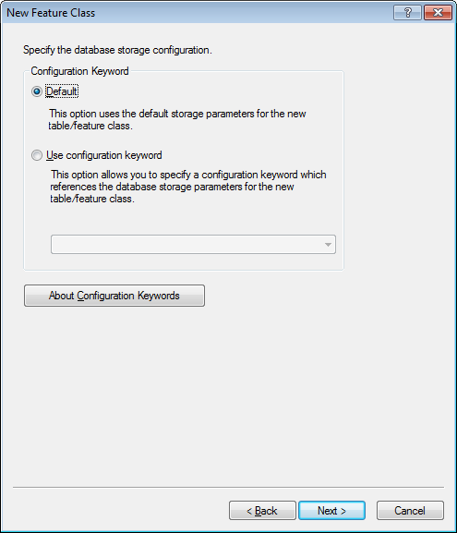  
     
   The above properties **may** **change** in production. If you are configuring for production, please check your sources for any configuration keywords that may be necessary.
4. Click “Next”.
5. For the next step, prepare by opening a connection to EDGISG1D. You can do this either in the same instance of ArcCatalog or open a new instance.
6. On the next screen, delete all fields that can be deleted by selecting the row and pressing the Delete key. If an error message appears, skip the field and try the next one. At the end of this step, you should have deleted all fields that you are able to delete from this list. Highlighting any row and clicking delete would give you an error. After doing this, click the “Import” button and navigate to the EDGISG1D database.  
   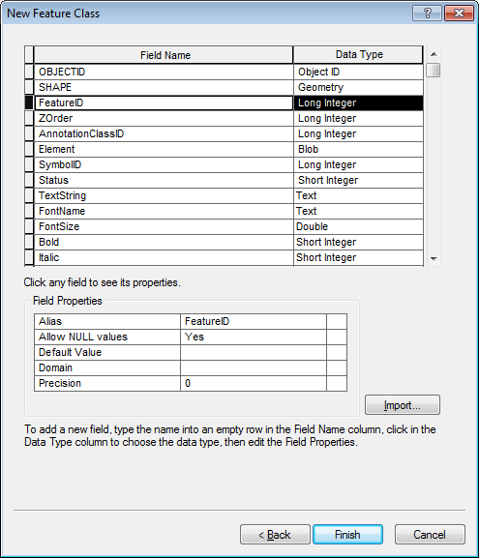
7. Select CustAgreeNumberAnno from G1D and the fields will be imported. Notice that there are ALL UPPERCASE duplicates of MixedCase fields. These will be deleted later.
8. Click “Finish”. A dialog will appear saying that there are duplicates being named with an appended “_1”. Press OK.
9. In ArcCatalog, right-click on the newly-created annotation feature class and click “Properties”.
10. 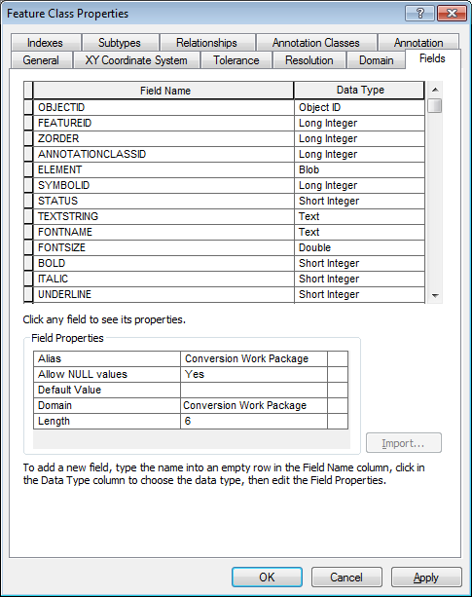Navigate to the “Fields” tab.
11. Delete all fields that have the “_1” appended. Compare to EDGISG1D to ensure accuracy.
12. In ArcCatalog, open the ElectricDataset, highlight the Anno relationship name Anno_####_#### and right click->Rename and rename it to “CustAgreeNumberAnno”.

# Modify Annotation Feature Class

## Modify StepDownAnno

1. Open ArcCatalog.
2. Within the Catalog Tree, expand “Database Connections” and open the active connection for this process (as defined in section 2).
3. Within the ElectricDataset, right-click on the “StepDownAnno” annotation feature class and click “Properties”.
4. Click on the “Annotation Classes” tab.  
     
   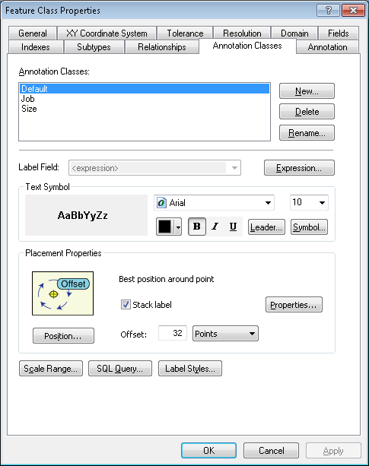
5. Click on the *Default* annotation class to begin modifying its attributes.  
   1. Under “Text Symbol”, click the “Symbol” button. Then click “Edit Symbol”.  
        
      
   2. Ensure that the settings under the “General” tab match the example below:  
        
      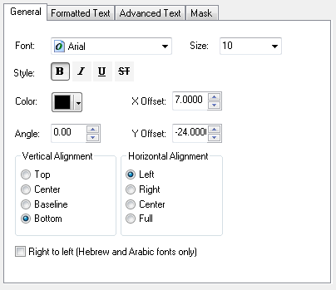
   3. Click “OK” to close this window.
   4. Click “OK” again. If changes were made, read and accept the warning.
   5. Under “Placement Properties”, click the “Properties” button.  
        
      
   6. 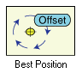In the Label Position tab, click the “Position” button and ensure the Position is set to Offset (“Best Position”).
   7. In the Label Position tab, click the “Label Offset” button and ensure that the preferred offset is **32**. Ensure that the “Measure offset from feature geometry” checkbox is unchecked.  
        
      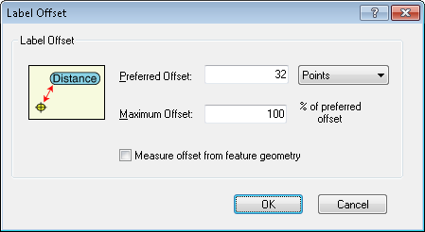
   8. In the “Fitting Strategy” tab, ensure that the “Stack Label” checkbox is checked.  
        
      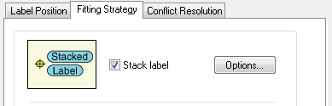
   9. Click “OK” to close this window and return to the Feature Class Properties window.
   10. Click “Expression” next to the Label Field dropdown.



* 1. Ensure that the “Display coded value description” checkbox is selected, match the label text with the text below, click verify, and then click “OK”.  
     *(Note: the contents of the expression field below may be copied)*   
     

Function FindLabel ( [OPERATINGNUMBER], [INSTALLATIONTYPE] )

if [INSTALLATIONTYPE] <> "Overhead" then

  FindLabel = [OPERATINGNUMBER]

end if

End Function

1. Click on the *Job* annotation class to begin modifying its attributes.  
   1. Under “Text Symbol”, click the “Symbol” button. Then click “Edit Symbol”.  
        
      
   2. Ensure that the settings under the “General” tab match the example below:  
        
      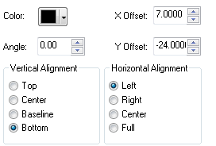
   3. Click “OK” to close this window.
   4. Click “OK” again. If changes were made, read and accept the warning.
   5. Under “Placement Properties”, click the “Properties” button.  
        
      
   6. In the Label Position tab, click the “Position” button and ensure the Position is set to Offset (“Best Position”).
   7. In the Label Position tab, click the “Label Offset” button and ensure that the preferred offset is **3**. Ensure that the “Measure offset from feature geometry” checkbox is unchecked.
   8. In the “Fitting Strategy” tab, ensure that the “Stack Label” checkbox is checked.  
        
      
   9. Click “OK” to close this window and return to the Feature Class Properties window.
   10. Click “Expression” next to the Label Field dropdown.



* 1. Ensure that the “Display coded value description” checkbox is selected, match the label text with the text below, click verify, and then click “OK”.  
     *(Note: the contents of the expression field below may be copied)*



Function FindLabel( [InstallJobPrefix], [InstallJobNumber], [InstallJobYear], [INSTALLATIONTYPE])

myString = ""

pad = ""

if [INSTALLATIONTYPE] = "Overhead" then

pad = vbCrLf + chr(129)

end if

if len([InstallJobPrefix]) > 0 then

myString = [InstallJobPrefix]

End If

if len([InstallJobYear]) > 0 then

if len([InstallJobYear]) = 4 then

FindLabel = myString + [InstallJobNumber] + " '"+ right([InstallJobYear],2) + pad

elseif len([InstallJobYear]) = 2 then

FindLabel = myString + [InstallJobNumber] + " '"+ [InstallJobYear] + pad

End if

Else

FindLabel = myString + [InstallJobNumber] + pad

end if

End Function

1. Click on the *Size* annotation class to begin modifying its attributes.  
   1. Under “Text Symbol”, click the “Symbol” button. Then click “Edit Symbol”.  
        
      
   2. Ensure that the settings under the “General” tab match the example below:  
        
      
   3. Click “OK” to close this window.
   4. Click “OK” again. If changes were made, read and accept the warning.
   5. Under “Placement Properties”, click the “Properties” button.  
        
      
   6. In the Label Position tab, click the “Position” button and ensure the Position is set to Offset (“Best Position”).
   7. In the Label Position tab, click the “Label Offset” button and ensure that the preferred offset is **12**. Ensure that the “Measure offset from feature geometry” checkbox is unchecked.
   8. In the “Fitting Strategy” tab, ensure that the “Stack Label” checkbox is checked.  
        
      
   9. Click “OK” to close this window and return to the Feature Class Properties window.
   10. Click “Expression” next to the Label Field dropdown.



* 1. Ensure that the “Display coded value description” checkbox is selected, match the label text with the text below, click verify, and then click “OK”.  
     *(Note: the contents of the expression field below may be copied)*



Function FindLabel ( [RatedKVA], [OperatingVoltage], [OutputVoltage], [INSTALLATIONTYPE]    )

myOplen = len([OperatingVoltage])

if myOplen > 1 then

  myVolt = mid( [OperatingVoltage],myOplen-1,1)

else

  myVolt = ""

end if

myOutlen = len([OutputVoltage])

if myOplen > 1 then

  myOut = mid([OutputVoltage] ,myOutlen-1,1)

else

  myOut = ""

end if

if myVolt = "k" then

    myVolt = mid([OperatingVoltage],1,myOplen-3)

else

    if myOplen > 2 then

      myVolt = mid([OperatingVoltage],1,myOplen-2)

   else

      myVolt = [OperatingVoltage]

   end if

end if

if myOut = "k" then

    myOut = mid([OutputVoltage],1,myOutlen-3)

else

    if myOutlen > 2 then

      myOut = mid([OutputVoltage],1,myOutlen-2)

    else

      myOut = [OutputVoltage]

    end if

end if

if [INSTALLATIONTYPE] = "Overhead" then

  FindLabel = [RatedKVA] + " kVA" + vbCrLf + myVolt + "/" + myOut + vbCrLf + chr(129)

else

  FindLabel = [RatedKVA] + " kVA" + vbCrLf + myVolt + "/" + myOut

end if

End Function

1. Click “OK” to save  
   your changes.

## Modify SupportStructureAnno

1. Open ArcCatalog.
2. Within the Catalog Tree, expand “Database Connections” and open the active connection for this process (as defined in section 2).
3. Within the ElectricDataset, right-click on the “SupportStructureAnno” annotation feature class and click “Properties”.
4. Click on the “Annotation Classes” tab.  
     
   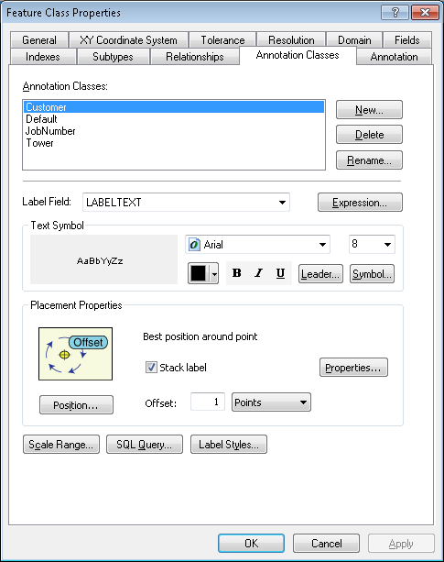
5. Click on the *Default* annotation class to begin modifying its attributes.  
   1. Under “Text Symbol”, click the “Symbol” button. Then click “Edit Symbol”.  
        
      
   2. Ensure that the settings under the “General” tab match the example below:  
        
      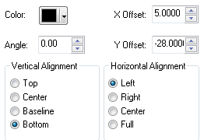
   3. Click “OK” to close this window.
   4. Click “OK” again. If changes were made, read and accept the warning.
   5. Under “Placement Properties”, click the “Properties” button.  
        
      
   6. In the Label Position tab, click the “Position” button and ensure the Position is set to Offset (“Best Position”).
   7. In the Label Position tab, click the “Label Offset” button and ensure that the preferred offset is **22**. Ensure that the “Measure offset from feature geometry” checkbox is unchecked.
   8. In the “Fitting Strategy” tab, ensure that the “Stack Label” checkbox is checked.  
        
      
   9. Click “OK” to close this window and return to the Feature Class Properties window.
   10. Click “Expression” next to the Label Field dropdown.



* 1. Ensure that the “Display coded value description” checkbox is selected, match the label text with the text below, click verify, and then click “OK”.  
     *(Note: the contents of the expression field below may be copied)*   
       
     

﻿Function FindLabel ( [SubtypeCD], [Height] , [Material], [JPNUMBER]  )  
MyString = ""  
If [SubtypeCD] = "Pole" then  
  If ucase([Material]) <> "WOOD" then  
    MyString = [Height] + "' " + [Material]  + " "  
  Else  
    MyString = [Height] + "' "  
  End If  
elseif [SubtypeCD] = "Push Brace" or [SubtypeCD] = "Guy Stub" or [SubtypeCD] = "Electrolier" or [SubtypeCD] = "Pole Stub" then  
  MyStringl = [Height] + "' "   
End If  
FindLabel = MyString  
End Function

1. Click on the *JobNumber* annotation class to begin modifying its attributes.  
   1. Under “Text Symbol”, click the “Symbol” button. Then click “Edit Symbol”.  
        
      
   2. Ensure that the settings under the “General” tab match the example below:  
        
      
   3. Click “OK” to close this window.
   4. Click “OK” again. If changes were made, read and accept the warning.
   5. Under “Placement Properties”, click the “Properties” button.  
        
      
   6. In the Label Position tab, click the “Position” button and ensure the Position is set to Offset (“Best Position”).
   7. In the Label Position tab, click the “Label Offset” button and ensure that the preferred offset is **13**. Ensure that the “Measure offset from feature geometry” checkbox is unchecked.
   8. In the “Fitting Strategy” tab, ensure that the “Stack Label” checkbox is checked.  
        
      
   9. Click “OK” to close this window and return to the Feature Class Properties window.
   10. Click “Expression” next to the Label Field dropdown.



* 1. Ensure that the “Display coded value description” checkbox is selected, match the label text with the text below, click verify, and then click “OK”.  
     *(Note: the contents of the expression field below may be copied)*



﻿Function FindLabel ( [InstallJobPrefix], [InstallJobNumber], [InstallJobYear], [JPNUMBER] )  
   
myString = ""  
if len([InstallJobPrefix]) > 0 then  
myString = [InstallJobPrefix]  
End If

if len([InstallJobYear]) > 0 then  
if len([InstallJobYear]) = 4 then  
  FindLabel = myString + [InstallJobNumber] + " '"+ right([InstallJobYear],2)  
elseif len([InstallJobYear]) = 2 then  
  FindLabel= myString + [InstallJobNumber] + " '"+ [InstallJobYear]  
End if  
Else  
  FindLabel= myString + [InstallJobNumber]  
end if  
End Function

1. Click on the *Tower* annotation class to begin modifying its attributes.
2. Under “Text Symbol”, click the “Symbol” button. Then click “Edit Symbol”.  
     
   
3. Ensure that the settings under the “General” tab match the example below:  
     
   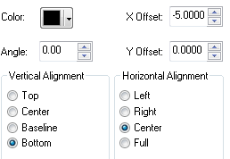
4. Click “OK” to close this window.
5. Click “OK” again. If changes were made, read and accept the warning.
6. Under “Placement Properties”, click the “Position” button and select “West”.  
     
   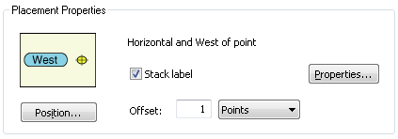
7. Click “Expression” next to the Label Field dropdown.



1. Ensure that the “Display coded value description” checkbox is selected, match the label text with the text below, click verify, and then click “OK”.  
   *(Note: the contents of the expression field below may be copied)*   
     
   

Function FindLabel ( [PoleUse] , [TransmissionMileNumber] , [TransmissionStructNumber]  )

If [PoleUse] = "1" or [PoleUse] = "Transmission" or [PoleUse] = "5" or [PoleUse] = "Transmission w/ Distribution" then

  FindLabel = [TransmissionMileNumber] & vbCrLf & "---" & vbCrLf & [TransmissionStructNumber]

End if

End Function

1. Click “OK” to save your changes.

## Modify TransformerAnno

1. Open ArcCatalog.
2. Within the Catalog Tree, expand “Database Connections” and open the active connection for this process (as defined in section 2).
3. Within the ElectricDataset, right-click on the “TransformerAnno” annotation feature class and click “Properties”.
4. Click on the “Annotation Classes” tab.  
     
   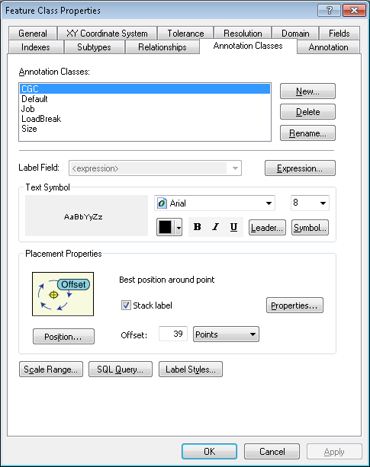
5. Click on the *CGC* annotation class to begin modifying its attributes.  
   1. Under “Text Symbol”, click the “Symbol” button. Then click “Edit Symbol”.  
        
      
   2. Ensure that the settings under the “General” tab match the example below:  
        
      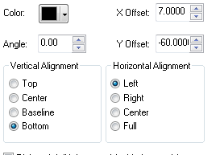
   3. Click “OK” to close this window.
   4. Click “OK” again. If changes were made, read and accept the warning.
   5. Under “Placement Properties”, click the “Properties” button.  
        
      
   6. In the Label Position tab, click the “Position” button and ensure the Position is set to Offset (“Best Position”).
   7. In the Label Position tab, click the “Label Offset” button and ensure that the preferred offset is **39**. Ensure that the “Measure offset from feature geometry” checkbox is unchecked.  
        
      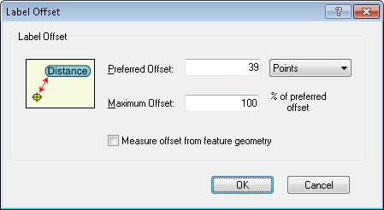
   8. In the “Fitting Strategy” tab, ensure that the “Stack Label” checkbox is checked.  
        
      
   9. Click “OK” to close this window and return to the Feature Class Properties window.
   10. Click “Expression” next to the Label Field dropdown.



* 1. Ensure that the “Display coded value description” checkbox is selected, match the label text with the text below, click verify, and then click “OK”.  
     *(Note: the contents of the expression field below may be copied)*



﻿﻿Function FindLabel ( [SUBTYPECD], [CGC12], [INSTALLATIONTYPE], [LABELTEXT])

pos1 = InStr (1, [LABELTEXT], chr(10))

if pos1 > 0 then

  pos2 = InStr(pos1 + 1, [LABELTEXT], chr(10))

else

 pos2 = -1

end if

if ( pos1 > 0) and (pos2 > 0) and (pos2 - pos1 > 1) then

  lineCount = 3

elseif pos1 > 0 then

  lineCount = 2

else

  lineCount = 1

end if

if  [SUBTYPECD] = "Distribution Overhead" or _

   ([SUBTYPECD] = "Equipment" and [INSTALLATIONTYPE] = "Overhead") or _

   ([SUBTYPECD] = "Street Light" and [INSTALLATIONTYPE] = "Overhead") or  _

   ([SUBTYPECD] = "Secondary" and [INSTALLATIONTYPE] = "Overhead") then

  myX = mid([CGC12],4,4)

  myY = mid([CGC12],9,4)

  if LineCount = 3 then

    FindLabel = myX + "-" + myY

  elseif LineCount = 2 then

    FindLabel = myX + "-" + myY + vbCrLf + chr(129)

  else

    FindLabel = myX + "-" + myY + vbCrLf +  chr(129) + vbCrLf +  chr(129)

  end if

end if

End Function

1. Click on the *Default* annotation class to begin modifying its attributes.  
   1. Under “Text Symbol”, click the “Symbol” button. Then click “Edit Symbol”.  
        
      
   2. Ensure that the settings under the “General” tab match the example below:  
        
      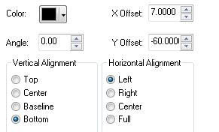
   3. Click “OK” to close this window.
   4. Click “OK” again. If changes were made, read and accept the warning.
   5. Under “Placement Properties”, click the “Properties” button.  
        
      
   6. In the Label Position tab, click the “Position” button and ensure the Position is set to Offset (“Best Position”).
   7. In the Label Position tab, click the “Label Offset” button and ensure that the preferred offset is **66**. Ensure that the “Measure offset from feature geometry” checkbox is unchecked.
   8. In the “Fitting Strategy” tab, ensure that the “Stack Label” checkbox is checked.
   9. Click “OK” to close this window and return to the Feature Class Properties window.
   10. Click “Expression” next to the Label Field dropdown.



* 1. Ensure that the “Display coded value description” checkbox is selected, match the label text with the text below, click verify, and then click “OK”.  
     *(Note: the contents of the expression field below may be copied)*   
       
     

﻿Function FindLabel ( [OPERATINGNUMBER], [SUBTYPECD], [INSTALLATIONTYPE] )

if [SUBTYPECD] <> "Distribution Overhead" then

  if IsNull( [INSTALLATIONTYPE] ) or _

   [INSTALLATIONTYPE] <> "Overhead" then

    FindLabel = [OPERATINGNUMBER]

 end if

end if

End Function

1. Click on the *Job* annotation class to begin modifying its attributes.
2. Under “Text Symbol”, click the “Symbol” button. Then click “Edit Symbol”.  
     
   
3. Ensure that the settings under the “General” tab match the example below:  
     
   
4. Click “OK” to close this window.
5. Click “OK” again. If changes were made, read and accept the warning.
6. Under “Placement Properties”, click the “Properties” button.  
     
   
7. In the Label Position tab, click the “Position” button and ensure the Position is set to Offset (“Best Position”).
8. In the Label Position tab, click the “Label Offset” button and ensure that the preferred offset is **30**. Ensure that the “Measure offset from feature geometry” checkbox is unchecked.
9. In the “Fitting Strategy” tab, ensure that the “Stack Label” checkbox is checked.  
     
   
10. Click “OK” to close this window and return to the Feature Class Properties window.
11. Click “Expression” next to the Label Field dropdown.



1. Ensure that the “Display coded value description” checkbox is selected, match the label text with the text below, click verify, and then click “OK”.  
   *(Note: the contents of the expression field below may be copied)*



﻿Function FindLabel ( [InstallJobPrefix], [InstallJobNumber], [InstallJobYear],  [LABELTEXT], [SUBTYPECD], [INSTALLATIONTYPE], [CGC12])

pos1 = InStr (1, [LABELTEXT], chr(10))

if pos1 > 0 then

  pos2 = InStr(pos1 + 1, [LABELTEXT], chr(10))

else

  pos2 = -1

end if

if ( pos1 > 0) and (pos2 > 0) and (pos2 - pos1 > 1) then

  lineCount = 3

elseif pos1 > 0 then

  lineCount = 2

else

  lineCount = 1

end if

if len([InstallJobPrefix]) > 0 then

  myString = [InstallJobPrefix]

End If

if len([InstallJobYear]) > 0 then

  if len([InstallJobYear]) = 4 then

    myString = myString + [InstallJobNumber] + " '"+ right([InstallJobYear],2)

  elseif len([InstallJobYear]) = 2 then

    myString = myString + [InstallJobNumber] + " '"+ [InstallJobYear]

  End if

Else

  myString  = myString + [InstallJobNumber]

end if

if [SUBTYPECD] = "Distribution Overhead" or _

   ([SUBTYPECD] = "Equipment" and [INSTALLATIONTYPE] = "Overhead") or _

   ([SUBTYPECD] = "Street Light" and [INSTALLATIONTYPE] = "Overhead") or _

   ([SUBTYPECD] = "Secondary" and [INSTALLATIONTYPE] = "Overhead") then

  if LineCount = 3 then

    FindLabel = myString

  elseif LineCount = 2 then

    FindLabel = myString + vbCrLf + chr(129)

  else

    FindLabel = myString + vbCrLf + chr(129) + vbCrLf + chr(129)

  end if

else

  FindLabel = myString + vbCrLf + chr(129) + vbCrLf + chr(129)

end if

End Function

1. Click on the *LoadBreak* annotation class to begin modifying its attributes.  
   1. Under “Text Symbol”, click the “Symbol” button. Then click “Edit Symbol”.  
        
      
   2. Ensure that the settings under the “General” tab match the example below:  
        
      
   3. Click “OK” to close this window.
   4. Click “OK” again. If changes were made, read and accept the warning.
   5. Under “Placement Properties”, click the “Properties” button.  
        
      
   6. In the Label Position tab, click the “Position” button and ensure the Position is set to Offset (“Best Position”).
   7. In the Label Position tab, click the “Label Offset” button and ensure that the preferred offset is **40**. Ensure that the “Measure offset from feature geometry” checkbox is unchecked.
   8. In the “Fitting Strategy” tab, ensure that the “Stack Label” checkbox is checked.
   9. Click “OK” to close this window and return to the Feature Class Properties window.
   10. Click “Expression” next to the Label Field dropdown.



* 1. Ensure that the “Display coded value description” checkbox is selected, match the label text with the text below, click verify, and then click “OK”.  
     *(Note: the contents of the expression field below may be copied)*   
       
     

﻿ ﻿Function FindLabel ( [SubtypeCD], [LiveFrontIdc], [LABELTEXT], [INSTALLATIONTYPE], [CGC12] )

If [SubtypeCD] = "Distribution Subsurface" or  [SubtypeCD] = "Distribution Padmount" then

  if [LiveFrontIdc] = "Yes" then

    FindLabel = "LF"

  End if

End If

End Function

1. Click on the *Size* annotation class to begin modifying its attributes.
2. Under “Text Symbol”, click the “Symbol” button. Then click “Edit Symbol”.  
     
   
3. Ensure that the settings under the “General” tab match the example below:  
     
   
4. Click “OK” to close this window.
5. Click “OK” again. If changes were made, read and accept the warning.
6. Under “Placement Properties”, click the “Properties” button.  
     
   
7. In the Label Position tab, click the “Position” button and ensure the Position is set to Offset (“Best Position”).
8. In the Label Position tab, click the “Label Offset” button and ensure that the preferred offset is **57**.
9. In the “Fitting Strategy” tab, ensure that the “Stack Label” checkbox is checked.  
     
   
10. Click “OK” to close this window and return to the Feature Class Properties window.
11. Click “Expression” next to the Label Field dropdown.



1. Ensure that the “Display coded value description” checkbox is selected, match the label text with the text below, click verify, and then click “OK”.  
   *(Note: the contents of the expression field below may be copied)*



﻿ ﻿﻿Function FindLabel ( [LABELTEXT], [SUBTYPECD], [INSTALLATIONTYPE]  )

MyString = [LABELTEXT]

pos1 = InStr (1, [LABELTEXT], chr(10))

if pos1 > 0 then

  pos2 = InStr(pos1 + 1, [LABELTEXT], chr(10))

else

  pos2 = -1

end if

if ( pos1 > 0) and (pos2 > 0) then

  lineCount = 3

elseif pos1 > 0 then

  lineCount = 2

else

  lineCount = 1

end if

if  [SUBTYPECD] = "Distribution Overhead" or _

   ([SUBTYPECD] = "Equipment" and [INSTALLATIONTYPE] = "Overhead") or _

   ([SUBTYPECD] = "Street Light" and [INSTALLATIONTYPE] = "Overhead") or _

   ([SUBTYPECD] = "Secondary" and [INSTALLATIONTYPE] = "Overhead") then

  if LineCount = 1 then

    FindLabel = chr(129) + vbCrLf  + MyString + vbCrLf + chr(129)

  elseif LineCount = 2 then

    FindLabel = MyString + vbCrLf + chr(129)

  else

    FindLabel = MyString + vbCrLf + chr(129)

  end if

else

    FindLabel = chr(129) +  vbCrLf + [LABELTEXT]

end if

FindLabel = replace(FindLabel, chr(10) + " ", chr(10))

End Function

1. Click “OK” to save your changes.

## Modify DynamicProtectiveDeviceAnno

1. Open ArcCatalog.
2. Within the Catalog Tree, expand “Database Connections” and open the active connection for this process (as defined in section 2).
3. Within the ElectricDataset, right-click on the “DynamicProtectiveDeviceAnno” annotation feature class and click “Properties”.
4. Click on the “Annotation Classes” tab.  
     
   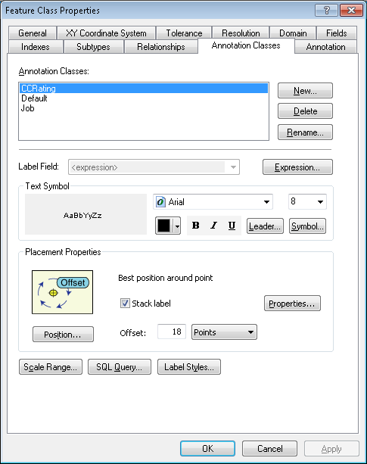
5. Click on the *CCRating* annotation class to begin modifying its attributes.  
   1. Under “Text Symbol”, click the “Symbol” button. Then click “Edit Symbol”.  
        
      
   2. Ensure that the settings under the “General” tab match the example below:  
        
      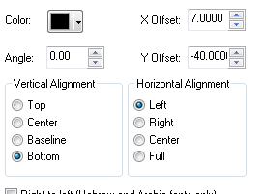
   3. Click “OK” to close this window.
   4. Click “OK” again. If changes were made, read and accept the warning.
   5. Under “Placement Properties”, click the “Properties” button.  
        
      
   6. In the Label Position tab, click the “Position” button and ensure the Position is set to Offset (“Best Position”).
   7. In the Label Position tab, click the “Label Offset” button and ensure that the preferred offset is **18**. Ensure that the “Measure offset from feature geometry” checkbox is unchecked.
   8. In the “Fitting Strategy” tab, ensure that the “Stack Label” checkbox is checked.
   9. Click “OK” to close this window and return to the Feature Class Properties window.
   10. Click “Expression” next to the Label Field dropdown.



* 1. Ensure that the “Display coded value description” checkbox is selected, match the label text with the text below, click verify, and then click “OK”.  
     *(Note: the contents of the expression field below may be copied)*   
     

Function FindLabel ( [SubtypeCD], [CCRating], [SwitchModeIdc]  )

If [SubtypeCD] = "Interrupter" and [SwitchModeIdc] = "Yes" then

    FindLabel =  [CCRating] + "-SM"

End if

End Function

1. Click on the *Default* annotation class to begin modifying its attributes.  
   1. Under “Text Symbol”, click the “Symbol” button. Then click “Edit Symbol”.  
        
      
   2. Ensure that the settings under the “General” tab match the example below:  
        
      
   3. Click “OK” to close this window.
   4. Click “OK” again. If changes were made, read and accept the warning.
   5. Under “Placement Properties”, click the “Properties” button.  
        
      
   6. In the Label Position tab, click the “Position” button and ensure the Position is set to Offset (“Best Position”).
   7. In the Label Position tab, click the “Label Offset” button and ensure that the preferred offset is **25**. Ensure that the “Measure offset from feature geometry” checkbox is unchecked.
   8. In the “Fitting Strategy” tab, ensure that the “Stack Label” checkbox is checked.
   9. Click “OK” to close this window and return to the Feature Class Properties window.
   10. Click “Expression” next to the Label Field dropdown.   
         
       
   11. Ensure that the “Display coded value description” checkbox is selected, match the label text with the text below, click verify, and then click “OK”.  
       *(Note: the contents of the expression field below may be copied)*   
       

Function FindLabel ( [SubtypeCD] ,[OperatingNumber] )

If [SubtypeCD] = "Recloser" or [SubtypeCD] = "Sectionalizer" or [SubtypeCD] = "Interrupter" then

  FindLabel = [OperatingNumber]

end if

End Function

1. 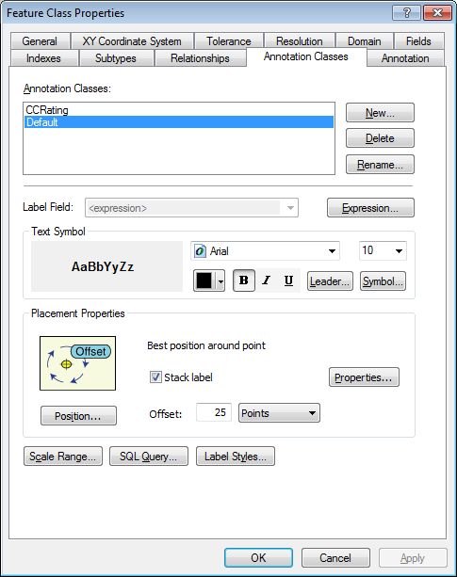For this last annotation class, we will have to create the *Job* anno class because it does not currently exist.Click “New” to the right of the Annotation Classes list.
2. Enter in “Job” as the name of the new annotation class and select the annotation class.

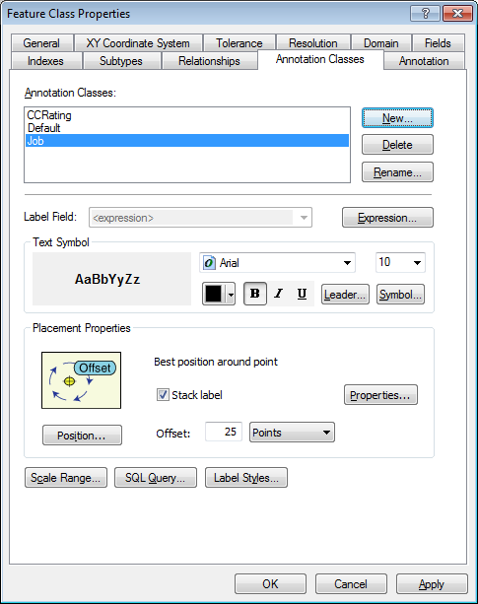

1. Under “Text Symbol”, click the “Symbol” button. Then click “Edit Symbol”.  
     
   
2. Ensure that the settings under the “General” tab match the example below:  
     
   
3. Click “OK” to close this window.
4. Click “OK” again. If changes were made, read and accept the warning.
5. Under “Placement Properties”, click the “Properties” button.  
     
   
6. In the Label Position tab, click the “Position” button and ensure the Position is set to Offset (“Best Position”).
7. In the Label Position tab, click the “Label Offset” button and ensure that the preferred offset is **9**. Ensure that the “Measure offset from feature geometry” checkbox is unchecked.
8. In the “Fitting Strategy” tab, ensure that the “Stack Label” checkbox is checked.  
     
   
9. Click “OK” to close this window and return to the Feature Class Properties window.
10. Click “Expression” next to the Label Field dropdown.



1. Ensure that the “Display coded value description” checkbox is selected, match the label text with the text below, click verify, and then click “OK”.  
   *(Note: the contents of the expression field below may be copied)*



Function FindLabel ( [InstallJobPrefix], [InstallJobNumber], [InstallJobYear], [SUBTYPECD],  [SWITCHMODEIDC]  )

if len([InstallJobPrefix]) > 0 then

  myString = [InstallJobPrefix]

End If

if len([InstallJobYear]) > 0 then

  if len([InstallJobYear]) = 4 then

   myString = myString + [InstallJobNumber] + " '"+ right([InstallJobYear],2)

  elseif len([InstallJobYear]) = 2 then

   MyString = myString +  [InstallJobNumber] + " '"+ [InstallJobYear]

  end if

else

  myString = myString +  [InstallJobNumber]

end if

If [SubtypeCD] = "Recloser" or [SubtypeCD] = "Sectionalizer" or [SubtypeCD] = "Interrupter" then

  If [SubtypeCD] <> "Interrupter" or [SWITCHMODEIDC] <> "Yes" then

     FindLabel = chr(129) + vbCrLf + myString +  vbCrLf +  chr(129)

else

    FindLabel = chr(129) + vbCrLf +  myString

end if

else

  FindLabel = chr(129) + vbCrLf + myString + vbCrLf + chr(129) + vbCrLf + chr(129)

end if

End Function

1. Click “OK” to save your changes.

# Modify Privileges For Electric Dataset

1. In order to view/write to the table we have dropped and re-created, we will need to enable privileges on them. Apply privileges to the Electric Dataset following the process below. Use the below table to reference the permissions that need to be applied (detail on how to use the table is provided further below).

|  |  |  |
| --- | --- | --- |
| Role | View | View & Edit |
| SDE_EDITOR | ConversionFeaturesDataset | All other datasets  *All EDGIS tables |
| SDE_VIEWER | All datasets  *All EDGIS tables |  |
| DAT_EDITOR | All other datasets  *All EDGIS tables | ConversionFeaturesDataset |
| **DATACONV | All datasets  *All EDGIS tables |  |
| **\*   = Except** EDGIS.*_BUILDERR & EDGIS.PGEDATAMODELVERSION  **\*\* = ONLY** QxQ & MxQ instances | | |

1. To do this, right click the ElectricDataset and select Privileges. Key in the first role, “SDE_EDITOR”, into the “User” field.

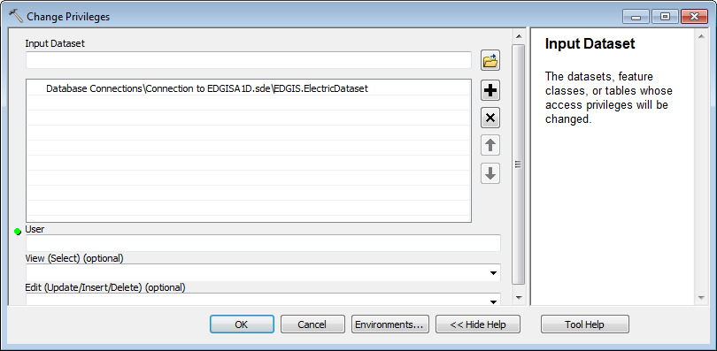

1. Select the dropdown for the View field and click “GRANT”.

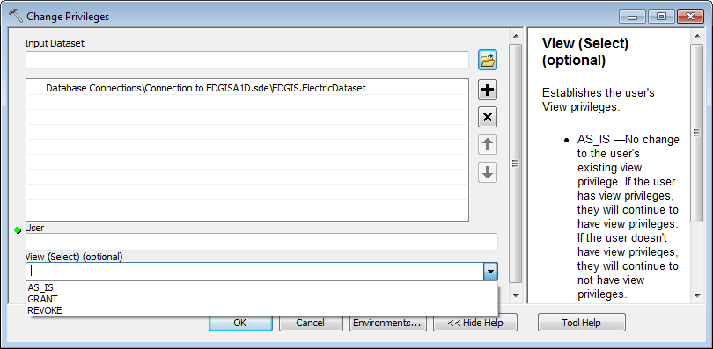

1. Select the dropdown for the Edit field and click “GRANT”.
2. Click OK to apply the privileges.
3. Open the Privileges dialog again and key in the second role, “SDE_VIEWER”, into the “User” field.
4. Select “GRANT” from the View dropdown.
5. Click OK to apply the changes.
6. Repeat steps 14-16 for the last two roles to finish applying privileges.

# Update Data Model Version Table

**Database Configuration:**

1. Open SQL Plus.
2. Log in using the same server and user as was used in section 2.  
     
   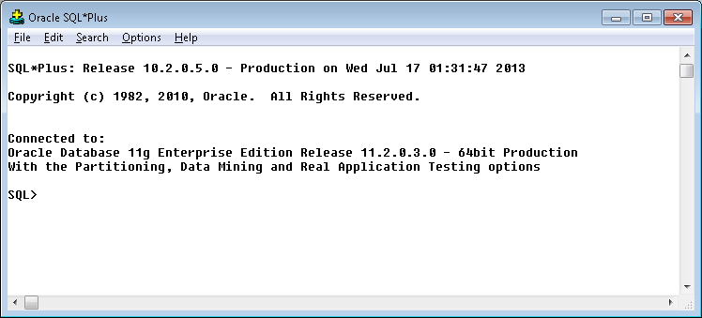
3. Run the SQL below:  
     
     
    update pgedatamodelversion set currentidc='N' where currentidc='Y';  
     
   insert into pgedatamodelversion (OBJECTID, CURRENTIDC, DATEAPPLIED, APPLIEDBYPERSONNAME, MODELVERSION) values (26,'Y',sysdate,'Rob Rader','7.5.4 CR8843');

**Next row in datamodelversion created because of last minute supportstructureanno change from Jon Ronat at 8:33AM on 7/17/13**

update pgedatamodelversion set currentidc='N' where currentidc='Y';

insert into pgedatamodelversion (OBJECTID, CURRENTIDC, DATEAPPLIED, APPLIEDBYPERSONNAME, MODELVERSION) values (27,'Y',sysdate,'Rob Rader','7.5.4 GOLD 2 CR8843');

# Known Issues

*No known issues have been discovered at this time.*